The Northwest Colonial Reenactors Association

Presents

Our 22nd Annual Colonial Encampment

Thursday September 12th to Sunday September 15th, 2024

In the secluded hinterlands of Sedro Woolley north of the mighty Skagit River

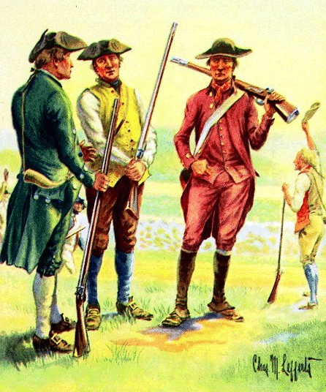

We will be enjoying multiple presentations and classes, bowls, teas, games, marching drills, shoots, trail walks, tomahawk throws, evening campfire conversations, raffle prizes, colonial dancing, and a fabulous potluck dinner that has to be tasted to be believed! As always, we will especially enjoy the endearing atmosphere of family fun, fellowship and camaraderie that has become the norm for this event each year. While our encampment is for reenactors dressed in period accurate attire and lodging in period camps, we have a non period camping area available as well. See the Upcoming Events tab on our website for further details:
ncra-colonial.com Wylin Tjoelker: 360-988-0404

